RAILWAY TRACK MONITORING AND ACCIDENT AVOIDING SYSYTEM

*Mini Project Submitted for the partial fulfilment of the requirement for the award of the degree of*

# Bachelor of Technology

*in*

## Electrical Engineering

**Dr. A.P.J. Abdul Kalam Technical University, Lucknow**

Submitted by

**Nandini Brhmarishi (2100910200045)**

**Nikhil Upadhyay (2100910200046)**

**Mohammad Saqib (2100910200042)**

**Sachin Jha (2100910200055)**

**Shivam Singh (2100910200056)**

Under the guidance of

## Mr.Udit Mittal & Mr.Abhishek Kumar Singh

Assistant Professor, Electrical Engineering Department



## Session: 2022-23 (ODD) Semester

**JSS MAHAVIDYAPEETHA**

## JSS Academy of Technical Education, Noida Department Of Electrical Engineering C-20/1, Sector – 62, Noida- 201301

**TABLE OF CONTENTS**

Page No. DECLARATION 2

ACKNOWLEDGEMENT 3

CERTIFICATE 4

ABSTRACT 5

LIST OF TABLES 6

LIST OF FIGURES 6

CHAPTER:1- Introduction

* 1. Introduction… 7
  2. Literature Review 8
  3. Block diagram 8

CHAPTER : 2- Details

* 1. Working and principle 9
  2. Circuit Diagram 10

CHAPTER :3- Components

* 1. Different Component 11
  2. Result 14

CHAPTER :4- Conclusion

4.1 Conclusion… 15

References 16

# DECLARATION

I hereby declare that this submission is my own work and that, to the best of my knowledge and belief, it contains no material previously published or written by another person nor material which to a substantial extent has been accepted for the award of any other degree or diploma of the university or other institute of higher learning except where due acknowledgement has been made in the text.

Signature of Student-1:

Student’s Name: Mohammad Saqib Roll No: 2100910200042

Signature of Student-2:

Student’s Name: Nandini Brhmarishi Roll No: 2100910200045

Signature of Student-3:

Student’s Name: Nikhil Upadhyay Roll No: 2100910200046

Signature of Student-4: Student’s Name: Sachin Jha Roll No: 2100910200055

Signature of Student-5: Student’s Name: Shivam Singh Roll No: 2100910200056

# ACKNOWLEDGEMENT

We have taken efforts in this project. However, it would not have been possible without the kind support and help of many individuals and organizations. I would like to extend my sincere thanks to all of them.

We are highly indebted to **Dr Sanjeev Kumar Sharma, Mr. Abhishek Kumar Singh** and **Mr.Udit Mittal** for their guidance and constant supervision as well as for providing necessary information regarding the project & also for their support in completing the project.

Finally, as one of the team members, I would like to appreciate all my group members for their support and coordination, I hope we will achieve more in our future endeavors.

**CERTIFICATE**

This is to certify that 3rd Semester Mini Project/ Internship Report (KEE-354) titled “**Railway Track Monitoring and Accident Prevention System**” which is submitted by: Nandini Brhmarishi (2100910200045), Nikhil Upadhyay (2100910200046) Mohammad Saqib (2100910200042) Sachin Jha (2100910200055) Shivam Singh (2100910200056) in partial fulfillment of the requirement for the award of degree B. Tech in Department of Electrical Engineering of J.S.S Academy of Technical Education, Noida, affiliated to Dr. A.P.J. Abdul Kalam University, Lucknow is a record of the candidates’ own work carried out by them under my supervision. The matter embodied in this thesis is original and has not been submitted for the award of any other degree.

|  |  |  |
| --- | --- | --- |
| **Mr. Abhishek Kumar Singh**  Assistant Professor,  Electrical Engineering Department  JSS Academy of Technical Education, Noida |  | **Mr. Udit Mittal**  Assistant Professor,  Electrical Engineering Department,  JSS Academy of Technical Education, Noida |

# ABSTRACT

Railway is the most popular and friendly transportation system of the largest part of the cities in the world.

The train is facing unexpected situation in travelling because of wrong signal, wrong track switching, insecure level crossing etc. for which collision have been occurred.

But we can avoid this unexpected collision and take prevention from the accident dynamically by using the collision detection technology which can be made by ultrasonic sound with a special embedded system.

# LIST OF TABLES

**TABLES PG. NO**

Table 3.1 List of Components 10

**LIST OF FIGURES**

**FIGURE PG. NO**

Fig.1: Railway track monitoring and accident preventing model 7

Fig.2: Block diagram 8

Fig.3: Circuit diagram 10

Fig.4: Arduino UNO 11

Fig.5: Buzzer 11

Fig.6: Ultrasonic senor 12

Fig.7: Male to female jumper wires 13

Fig.8: Male to male jumper wires… 13

**INTRODUCTION**

***Chapter 1***

Anti-Collision Technology (ACT) is an innovative technology which can be detect collision object from specific distance of train and avoid collision dynamically and efficiently by using ultrasound and embedded system.

The proposed system is an enhanced technique for monitoring the object which uses Arduino microcontroller, ultrasonic sensor, and radar module.

The radar will get the distance from the object.

Ultrasonic sensors work by emitting sound waves at a frequency too high for humans to hear. They then wait for the sound to be reflected back, calculating distance based on the time required. This is similar to how radar measures the time it takes a radio wave to return after hitting an object. Ultrasonic sensor will ensure to avoid the accidents that may occur by the clash between the train and objects.

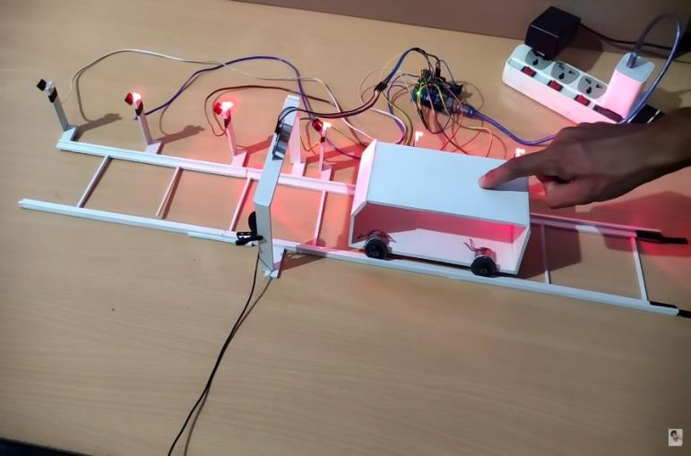

***Fig.1:Schematic model of railway track monitoring and accident avoiding system***

## 1.1 Literature Review

The proposed system is an enhanced technique for monitoring the object which uses Arduino microcontroller, ultrasonic sensor, and radar module. The radar will get the distance from the object and ultrasonic sensor will ensure to avoid the accidents that may occur by the clash between the train and objects.

Our project is mainly developed to avoid accidents due to carelessness of people walking on

Railway tracks. In a simple word, it works like if a man is standing on a railway track and train is 500 meters in front of him then buzzer and the lights will automatically turned on until the man doesn’t get out of the railway track and if it there is no man standing on the railway track.

Then lights and buzzer will remain turned off i.e. not wasting further energy. Now for further understanding, if a man is standing on a railway track the proximity sensor will sense the presence of an object and if the object(i.e. a man) is present then sensor will give low as an output which will act as TRUE for the first if statement of the program. This in turn will turn on the ultrasonic sensor which will further detect the distance of the train from itself and if the distance between the train and the man is 500 meter then the buzzer and the lights between the man and train will turn on automatically until the man gets off the railway track. And if there is no man standing on the railway track then the proximity sensor will give HIGH as an output which will act as FALSE for the first .

If statement thus lights and buzzer will not turn on and thus not wasting further energy .

The mode of communication between the lights and the ultrasonic sensor is Arduino UNO.

Arduino is programmed accordingly to work as it is desired too.

Arduino is programmed through the software named as Arduino IDE.

Code in the ARDINO is uploaded through a USB cable connected to the laptop for working of the Arduino.

This project is beneficial for the rural area where sometimes peoples doesn’t see the approaching train which result in causality.

# Block Diagram:

**BATTERY**

**ARDUINO UNO**

**ULTRASONIC SENSOR**

**LED AND BUZZER**

***Fig.2:Block diagram***



**CODE :**

**const int trigPin = 12;**

**const int echoPin = 13;**

**const int LED1 = A0;**

**const int LED2 = A1;**

**const int LED3 = A2;**

**const int LED4 = A3;**

**const int LED5 = A4;**

**const int LED6 = A5;**

**const int LED7 = 2;**

**int duration = 0;**

**int distance = 0;**

**void setup() {**

**pinMode(trigPin , OUTPUT); pinMode(echoPin , INPUT);**

**pinMode(LED1 , OUTPUT);**

**pinMode(LED2 , OUTPUT);**

**pinMode(LED3 , OUTPUT);**

**pinMode(LED4 , OUTPUT);**

**pinMode(LED5 , OUTPUT);**

**pinMode(LED6 , OUTPUT);**

**pinMode(LED7 , OUTPUT);**

**pinMode(3,INPUT);**

**Serial.begin(9600);**

**}**

**void loop() {**

**digitalWrite(trigPin, LOW); delayMicroseconds(2);**

**digitalWrite(trigPin, HIGH); delayMicroseconds(10); digitalWrite(trigPin, LOW);**

**duration = pulseIn(echoPin, HIGH); distance = duration/58.2;**

**if(digitalRead(3)==HIGH){**

**if ( distance <= 7 ) {**

**digitalWrite(LED1, HIGH);**

**}**

**else**

**{ digitalWrite(LED1, LOW);**

**}**

**if ( distance <= 14 ) {**

**digitalWrite(LED2, HIGH);**

**}**

**else{**

**digitalWrite(LED2, LOW);**

**}**

**if ( distance <= 21 ) {**

**digitalWrite(LED3, HIGH);**

**}**

**else{**

**digitalWrite(LED3, LOW);**

**}**

**if ( distance <= 28 ) {**

**digitalWrite(LED4, HIGH);**

**}**

**else{**

**digitalWrite(LED4, LOW);**

**}**

**if ( distance <= 35 ){**

**digitalWrite(LED5, HIGH);**

**}**

**else{**

**digitalWrite(LED5, LOW);**

**}**

**if ( distance <= 42 ){**

**digitalWrite(LED6, HIGH);**

**}**

**else{**

**digitalWrite(LED6, LOW);**

**}**

**if ( distance <= 49 ) {**

**digitalWrite(LED7, HIGH);**

**}**

**else {**

**digitalWrite(LED7, LOW);**

**}**

**delay(100);**

**}**

**}**

***Chapter 2***

## Working and Principle :

Ultrasonic sensor will ensure to avoid the accidents that may occur by the clash between the train and objects. Ultrasonic sensors work by emitting sound waves at a frequency too high for humans to hear.

They work by emitting sound waves at a frequency too high for humans to hear. They then wait for the sound to be reflected back, calculating distance based on the time required. This is similar to how radar measures the time it takes a radio wave to return after hitting an object. Ultrasonic sensor will ensure to avoid the accidents that may occur by the clash between the train and object.

The distance will be measured by Distance L = 1/2 × T × C where L is the distance, T is the time between the emission and reception, and C is the sonic speed. (The value is multiplied by 1/2 because T is the time for go-and-return distance.

All the components of the system are connected with the control unit.

9

* 1. **List of components:**

|  |  |  |  |
| --- | --- | --- | --- |
| **SI**  **No.** | **Components** | **Quantity** | **Specifications** |
| **1.** | **Arduino UNO** | **1** | **Atmega328**  **I/N voltage: 7- 12v**  **O/T voltage:6- 20v** |
| **2.** | **Battery** | **1** | **7.4 volts** |
| **3.** | **Ultrasonic sensor** | **1** | **30-500KHz** |
| **4.** | **Sunboard Sheet** | **1** | **-** |
| **5.** | **4x wheels** | **4** | **-** |
| **6.** | **Jumper wires** | **As per requirements** | **-** |
| **7.** | **LED lights and buzzer** | **As per requirements** | **-** |

# Circuit Diagram :

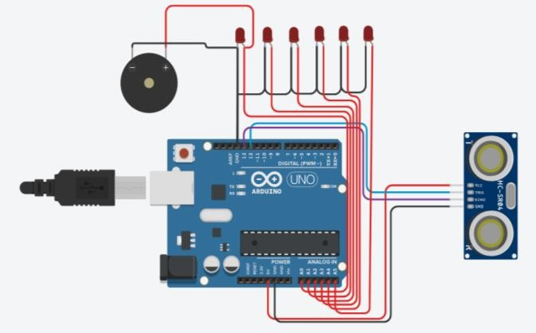

***Fig.3:Circuit diagram***

10

***Chapter 3***

# Components

The various components of the project are listed as per the following;

### Arduino UNO

A Micro controller comprises of an incredible CPU firmly combined with memory, different I/O interfaces, for example, sequential port, parallel port clock or counter, intrude on controller, information procurement interfaces-Analog to Digital converter, Digital to Analog converter, coordinated on to a solitary silicon chip. In the event that a framework is created with a chip, the originator needs to go for outside memory, for example, RAM, ROM, EPROM and peripherals. In any case, controller is given every one of these offices on a solitary chip.

Advancement of a Microcontroller lessens PCB size and cost of plan.

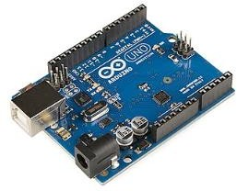

***Fig .4: Schematic of the Arduino UNO***

### Buzzer

A buzzer or beeper is an audio signaling device, which may be mechanical or electromechanical. The work of buzzer is that whenever an unauthorized card scan than it starts beeping.

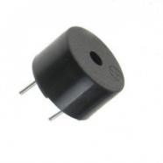

***Fig.5: Schematic of the Buzzer***

### Ultrasonic Sensor

An ultrasonic sensor transmits ultrasonic waves into the air and detects reflected waves from an object. There are many applications for ultrasonic sensors, such as in intrusion alarm systems, automatic door openers and backup sensors for automobiles. Accompanied by the rapid development of information processing technology, new fields of application, such as factory automation equipment and car electronics, are increasing and should continue to do so. Using its unique piezoelectric ceramics manufacturing technology developed over many years, Murata has developed various types of ultrasonic sensors which are compact and yet have very high performance. As the name indicates, ultrasonic sensors measure distance by using ultrasonic waves. The sensor head emits an ultrasonic wave and receives the wave reflected back from the target. Ultrasonic Sensors measure the distance to the target by measuring the time between the emission and reception. An optical sensor has a transmitter and receiver, whereas an ultrasonic sensor uses a single ultrasonic element for both emission and reception. In a reflective model ultrasonic sensor, a single oscillator emits and receives ultrasonic waves alternately. This enables miniaturization of the sensor head.

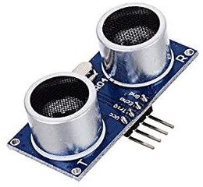

***Fig.6: Schematic of the Ultrasonic Sensor***

### Male to female jumper wires

These are male to female jumper wires used in connecting the female header pin of any development board to other development boards having a male connector. They are simple wires that have connector pins at each end allowing them to be used to connect two points to each other.

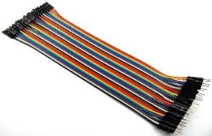

***Fig.7: Schematic of the Male to female jumper wires***

### Male to male jumper wire

These are male to male jumper wires with a connector or pins at each end. These wires normally for interconnecting the components of a breadboard.

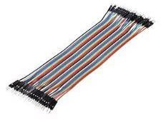

***Fig.8: Schematic of the Male to male jumper wires***

**Result:**

In the proposed system we are usingUltrasonic sensor. The sensor is attached in the train path. In the receiver side.In the transmitter side the sensor the signals and converts into electrical energy.

Ultrasonic sensors (also known as transceivers) work on a principle similar to radar or sonar which evaluate attributes of a target by interpreting the echoes from radio or sound waves respectively.Ultrasonic sensors generate high frequency sound waves and evaluate the echo which is received back by the sensor.

Motor drivers act as current amplifiers since they take a low-current control signal and provide a highercurrent signal.This higher current signal is used to drive the motors L293D contains two inbuilt H-bridge driver circuits. In its common mode of operation, two DC motors can be driven simultaneously, both in forward and reverse direction.

This gives a clear description of the working of the collision avoiding system. All the components of the system are connected with the control unit. The power supply supplies the power to the control unit. In this project we can design an automatic accident preventing system for train. The ultrasonic sensors are used to detect the obstacles in the train path.

Ultrasonic sensors work on a principle similar to sonar which evaluates distance of a target by interpreting the echoes from ultrasonic sound waves. This ultrasonic module measures the distance accurately which provides 0cm - 400cm with a gross error of 3cm. Its compact size, higher range and easy usability make it a handy sensor for distance measurement and mapping. The module can easily be interfaced to micro controllers where the triggering and measurement can be done using two pins.

The sensor transmits an ultrasonic wave and produces an output pulse that corresponds to the time required for the burst echo to return to the sensor. By measuring the echo pulse width, the distance to target can easily be calculated and also detects the obstacles in the path. If any obstacles are found in the path of the train the message will be conveyed to the monitoring unit of the TRA

***Chapter 3***

# Conclusion:

The simulation has been done using Tinkercad (SOFTWARE) and testing has been carried out using the established model.

It has remained projected that if the system is applied in railways, trains accidently on the International Journal of Advanced Research in Electronics and Communication Engineering (IJARECE) Volume 4, Issue 1, January 2015 71 ISSN: 2278 – 909X.

Collison of human with train can be avoided and human life can be saved if this scheme is implemented.

The result of the experiement can be used in saving lives due to not hearing the upcoming train sound. Then the scheme is completely automatic it can be used in remote villages. Also, it saves lot of human times as it is automated whereas manual systems take time.

Also, since it is completely automated there are fewer chances for error to occur. Thus, this design is very useful in railway applications.

15

# Reference:

RanuDewangan, Pratibhadevi Umesh “Automatic Accident Control Sysem on Railway Tracks” International Journal of Advanced Research in Electronics and Communication Engineering(IJARECE) Volume 5, Issue 7, July 2016.

Ms.K.Divya&Ms.R.Anjugam “Railway Safety Monitoring System using Ultrasonic and IR Sensor” IJSRD- International Journal for Scientific Research & Development vol. 5, Issue 01, 2017/ ISSN(Online):2321-0613.

SarathChandran.P, Karthika.M “IOT Based Accident Prevention and Monitoring System In Railways” International Journal of Advanced Research Trends in Engineering and Technology(IJARTET) VOL. 5, Special Issue 5, March 2018

RinkeshKumar Yadav, Rohini Temkar “Combined Iot and Cloud Computing Solution for Railway Accident Avoidance “International Research Journal of Engineering and

Technology(IRJET) VOL: 4, Issue: 06|June 2017.

Swati H. Patil, Aditya N. Waikar, Shweta S. Zarkar, Sakshi D. Wankhade, Rutuja B. Gadekar

“Obstacle Detection.

On Railway Track For Avoiding Accidents” International Journal of Pure and Applied

Mathematics. Vol 118 No 24 2018. ISSN: 1314- 3395

Prof.S.B.Deokar, Ashwini D.Kadam, Neha D.Pachupate, Nilam D. Kudale “Iot Based Railway Track Monitoring System Using Ultrasonic Sensor” Open Access International Journal of Science & Engineering. Vol: 3| Special Issue 1| March 2018 ISO 3297:2007 Certified ISSN(Online)2456-3293.

16